The potentiometer provides an analog input that is read by the Arduino. This value is mapped to PWM signals to control the brightness of red, green, and blue channels of the RGB LED. It also adjusts the blinking speed of another LED.
link:https://www.tinkercad.com/things/i751bAYvyfA/editel?returnTo=%2Fdashboard%2Fdesigns%2Fcircuits&sharecode=Oz3Yh26DRw6zATvME560wKx-xtv0WnRzHhKas_Es1wc

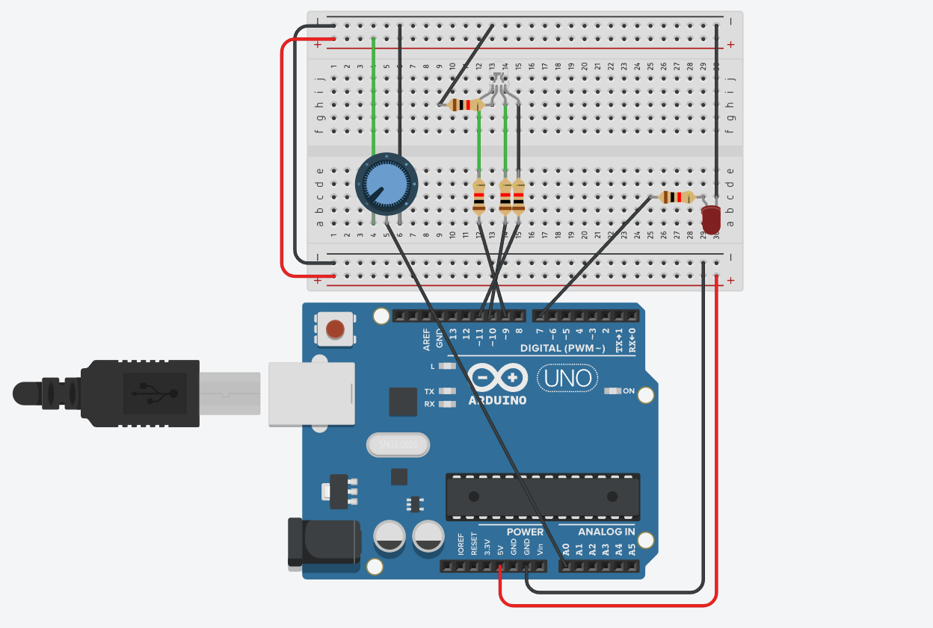

Programme
int potPin = A0;

int redPin = 11;
int greenPin = 9;
int bluePin = 10;

int ledPin = 7;

unsigned long previousTime = 0;
int ledState = LOW;

void setup() {
pinMode(redPin, OUTPUT);
pinMode(greenPin, OUTPUT);
pinMode(bluePin, OUTPUT);
pinMode(ledPin, OUTPUT);
}

void loop() {

int potValue = analogRead(potPin); // 0–1023

// Divide range into 3 zones for smooth color change
int red = 0, green = 0, blue = 0;

if (potValue < 341) {
red = 255 - map(potValue, 0, 340, 0, 255);
green = map(potValue, 0, 340, 0, 255);
blue = 0;
}
else if (potValue < 682) {
red = 0;
green = 255 - map(potValue, 341, 681, 0, 255);
blue = map(potValue, 341, 681, 0, 255);
}
else {
red = map(potValue, 682, 1023, 0, 255);
green = 0;
blue = 255 - map(potValue, 682, 1023, 0, 255);
}

// Apply colors
analogWrite(redPin, red);
analogWrite(greenPin, green);
analogWrite(bluePin, blue);

// Control blinking speed
int interval = map(potValue, 0, 1023, 200, 1500);

unsigned long currentTime = millis();

if (currentTime - previousTime >= interval) {
previousTime = currentTime;
ledState = !ledState;
digitalWrite(ledPin, ledState);
}
}

